Thermal Monitor User Guide
用户指南

1 Thermal Monitor

1.1 Introduction
- 高低溫會影響wifi 特性，因此需要定期檢查chip的溫度去做高低溫的補償。

1.2 flash layout
- flash layout 配置
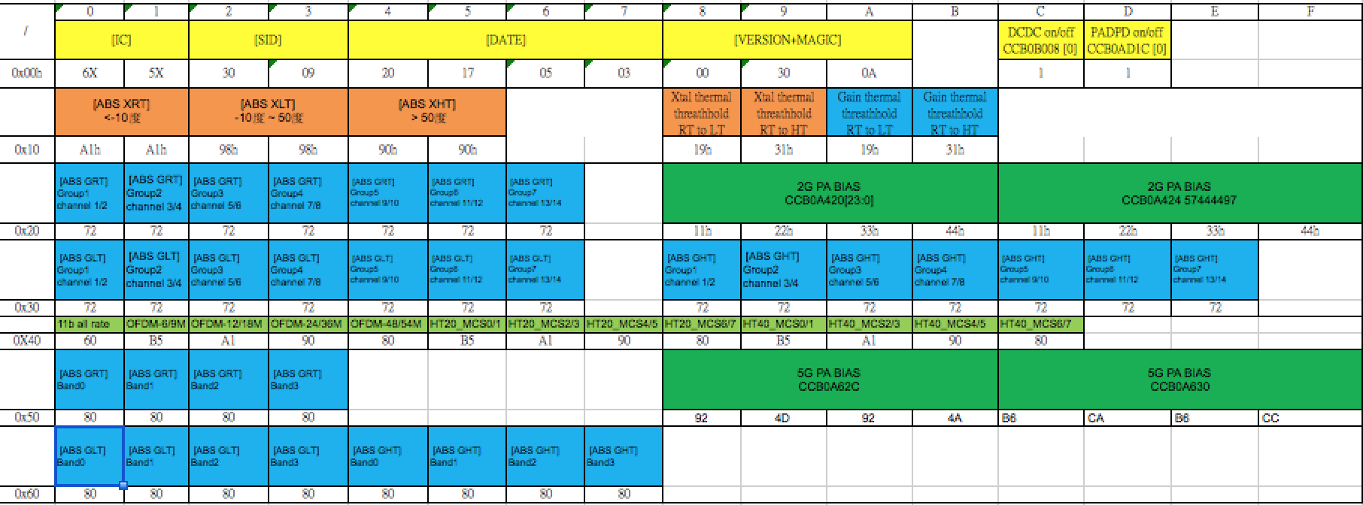

1.3 flash bin檔的產生與路徑

- 利用flash_bin_util即可產生flash.bin
可利用修正flash_bin_util.c 即可修正flash layout中各個參數值
- flash bin檔預設的路行為/system/etc/wifi/ssv6x5x/flash.bin
- 修正ssv6x5x-wifi.cfg 能指定flash.bin 的路徑
例如:
flash_bin_path = /etc/wifi/ssv6x5x/flash.bin

1.4检测 register 是否與flash.bin 的參數值相同
  - 2G PA BIAS
- reg 0xccb0a420 = 0x0033e73f
- reg 0xccb0a424 = 0x57444497
  - 5G PA BIAS
- reg 0xccb0a62c = 0x924d924a
- reg 0xccb0a630 = 0xb6cab6cc
  - DCDC mode
    - reg 0xccb0b008 = 0x486041bf [check bit0]
  - PADPD mode
    - reg 0xccb0ad1c = 0x00000001 [check bit0]
  - xtal frequency offset
    - reg 0xccb0b000 = 0x252e9714 [check bit8~bit16, bit17~bit25]
      - bit8 ~ bit16 cbanki
      - bit17~bit25 cbanko
  - rate bbscale
    - cck reg 0xccb0e180 = 0x00010060 [check bit0~bit7]
    - ofdm reg 0xccb0e184 = 0xb5a19080
      - 64QAM bit0~bit7
      - 16QAM bit8~bit15
      - QPSK bit16~bit23
      - BPSK bit24~bit31
    - ht20 reg 0xccb0e188 = 0xb5a19080
      - 64QAM bit0~bit7
      - 16QAM bit8~bit15
      - QPSK bit16~bit23
      - BPSK bit24~bit31
    - ht40 reg 0xccb0e18c = 0xb5a19080
      - 64QAM bit0~bit7
      - 16QAM bit8~bit15
      - QPSK bit16~bit23
      - BPSK bit24~bit31
  - Band gain
    - 2.4G band gain
      - reg 0xccb0adac = 0x00000072 [check bit0~bit7]
    - 5G band gain
      - reg 0xccb0ada8 = 0x806c6c66
      - band0 bit24~bit31
      - band1 bit16~bit23
      - band2 bit8~bit15
      - band3 bit0~bit7
      - 注意: 只有切換到5G channel，band gain設定值才會更新

